**Launching a new EC2 instance. Status Reason: Your quota allows for 0 more running instance(s). You requested at least 1. Launching EC2 instance failed**

**Launching a new EC2 instance. Status Reason: Your quota allows for 0 more running instance(s). You requested at least 1. Launching EC2 instance failed**

This error may comes while instance launching manually or through auto scale as well . The reason is you

reached on-demand running instance limit on that specific region . You need to increase the limit through AWS service ticket.

**Go to EC2 Dashboard -Click “Limits”**

[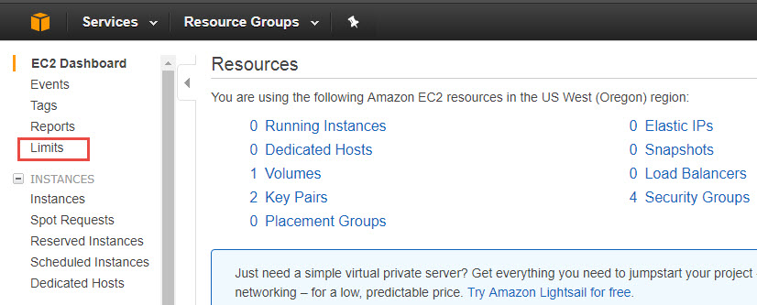](http://findoutthat.com/wp-content/uploads/2017/08/lim1.jpg)

Instance running limits shows **20** . You can increase to new required count.May be 50 or 100..

[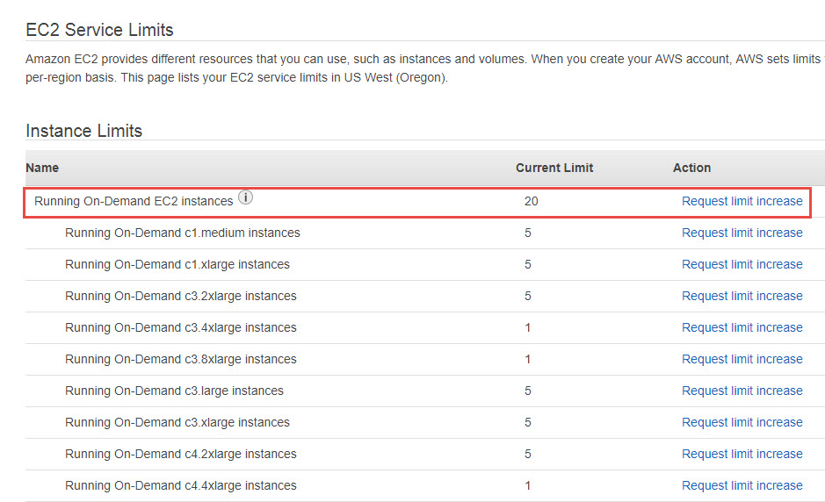](http://findoutthat.com/wp-content/uploads/2017/08/lim2.jpg)

**Click “Request Limit Increase” and submit the form**

[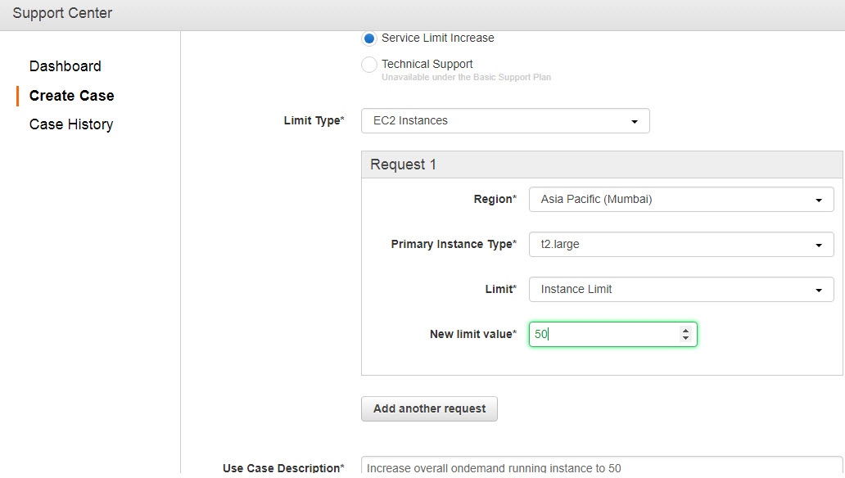](http://findoutthat.com/wp-content/uploads/2017/08/lim4.jpg)

AWS support team will reach you over phone or mail and they will increase the limits to new value.